When governments set climate targets, such as “net zero by 2050”, they need a way to test whether those promises are achievable, affordable, and fair. Enter the Integrated Assessment Model (IAM): a tool that combines insights from macroeconomics and climate science to understand how the economy drives climate change and how climate change, in turn, affects the economy.
The first IAM was introduced in 1975 by William Nordhaus, who was later awarded the 2018 Nobel Prize in Economics for “integrating climate change into long-run macroeconomic analysis.” Since then, IAMs have become the workhorses behind many of the numbers that shape climate debates, most notably the social cost of carbon (SC-CO₂).
In this opening article, we outline what IAMs are and why they matter. We also explain key concepts such as the SC-CO₂. In later articles we will explore, among other things, how IAMs measure damages, handle fairness, model technology, and more.

What is an Integrated Assessment Model?
At its core, an IAM is a macroeconomic framework that links human activity and the natural environment. It’s a simplified representation of how the economy and the climate interact, capturing feedback in both directions: how production and energy use drive emissions, and how climate change, in turn, affects the economy. Unlike tools that study just one part of the system - say, an energy-market model or a climate simulation - IAMs integrate these dynamics within a unified framework.
They typically include three interlinked building blocks that form a feedback loop between the economy, the carbon system, and the climate system
- Economy: A macroeconomic growth model, often neoclassical, that maximises the welfare of a representative agent, while accounting for policies such as carbon taxes or renewables subsidies. Economic activity requires energy and therefore generates greenhouse gas emissions that enter the carbon system.
- Carbon System: How emissions from the economy accumulate in the atmosphere and oceans, determining the concentration of greenhouse gases over time.
- Climate System: How the Earth’s system reacts to those greenhouse gas concentrations, determining temperature increases, sea-level rise, and other physical impacts.
A so-called damage function, which represents how impacts from the climate system harm the economy, then completes the feedback loop. These damage functions are so essential to IAMs that they will be the focus of the next article in this series. However, as we will see, they are often incomplete.
We have neatly summarised these interlinked building blocks in the figure below.
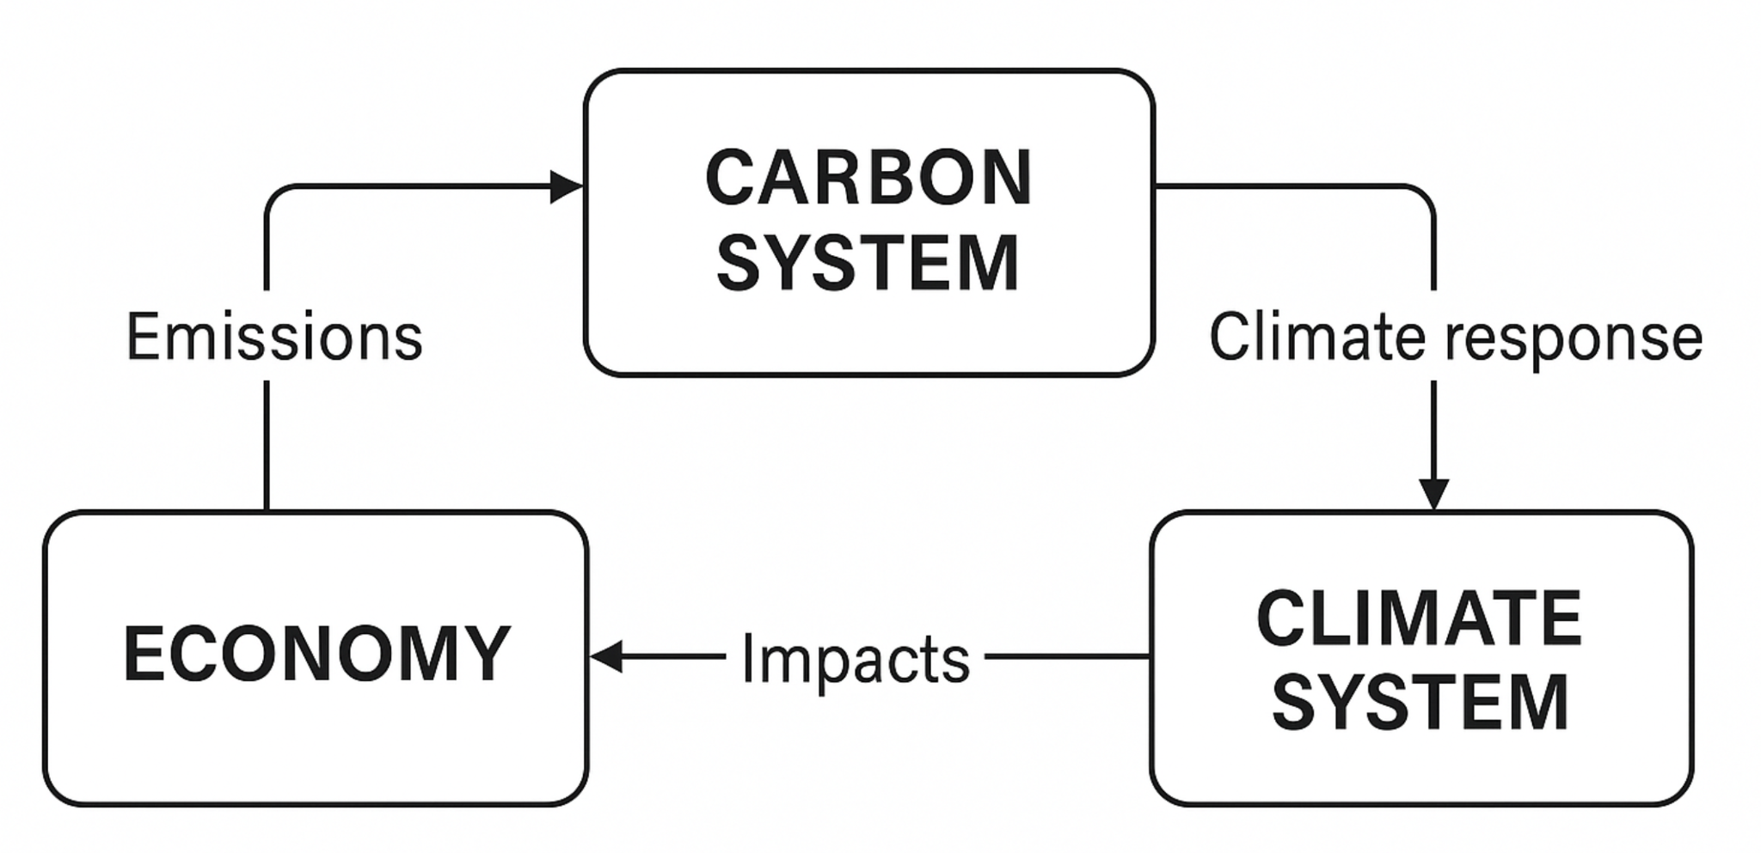
Some IAMs are simplified or “top-down” models, designed for fast exploration of trade-offs at the global level (e.g. DICE, PAGE, FUND). These treat the economy as a single aggregate system and focus on overall dynamics rather than sectoral detail. Others are much more detailed, “bottom-up”, models (e.g. REMIND, GCAM, WITCH), which build the economy from its components, including different energy sectors, technologies, and regions.

Why do IAMs matter?
IAMs matter because they connect policy choices today with economic and environmental outcomes tomorrow. They are used in three broad ways:
- Policy design: IAMs estimate the SC-CO₂ and simulate the impact of policies such as carbon taxes or renewables subsidies, allowing the comparison of options.
- Target setting: IAM scenarios translate carbon budgets - defined by climate science - into feasible economic pathways.
- Trade-offs: IAMs help identify which policies minimise overall costs and how benefits are distributed over time.

Key Concepts: The Social Cost of Carbon and Carbon Budgets
Social Cost of Carbon (SC-CO₂): The estimated monetary value of the global economic damage caused by emitting one additional tonne of CO₂, expressed in present-value terms. In economic terms, it represents the marginal external cost of emissions, that is, the negative externality impose on society by one more tonne of CO₂. This makes the SC-CO₂ conceptually elegant: it directly identifies the optimal carbon price or tax that would internalise this externality and align private incentives with social welfare.
Governments, particularly in the United States, have used the SC-CO₂ to guide climate regulations and evaluate the costs and benefits of emission-reduction policies.
Carbon Budget: The total cumulative amount of CO₂ that can be emitted while keeping global warming below a specific temperature limit (for example, 1.5°C or 2°C). Carbon budgets are derived from climate science and are used to define the physical limits within which mitigation pathways must fit. Unlike the SC-CO₂, however, they are normative rather than derived: the target temperature is set outside the model, and the budget follows from that choice rather than from an economic optimisation.
The European Union and many international organisations use carbon budgets as the starting point for setting net-zero targets.
In principle, both approaches should yield the same emissions pathway for a given economy if based on consistent assumptions.
In short: the US approach prices the social cost of carbon; the European approach caps the total of emissions.

Case Study 1: IAMs and the IPCC
The Intergovernmental Panel on Climate Change (IPCC) relies heavily on IAMs to translate physical-science goals—such as limiting warming to 1.5 °C—into coherent policy pathways.
For its Sixth Assessment Report (2021–22), the IPCC compiled results from dozens of IAMs to produce hundreds of global scenarios. Each scenario linked assumptions about population, technology, and policy choices to projections of emissions, temperatures, and economic outcomes. The resulting Shared Socioeconomic Pathways (SSPs) allow researchers to compare consistent storylines, such as a fossil-fuel-intensive world (SSP5-8.5) or a sustainability-focused one (SSP1-1.9).
IAMs were not strictly necessary to calculate the carbon budget for a given temperature target (since that relationship depends primarily on the physical link between emissions and warming) but they were essential for showing how that budget could be met through economic and technological transitions, even if the temperature target itself was set outside the model. In other words, IAMs translate the physics of carbon budgets into feasible policy pathways.
These model-based pathways informed the 2021 Glasgow Climate Pact and continue to guide the Paris Agreement’s Global Stocktake process. While policymakers may not run IAMs themselves, the IPCC’s synthesis, which is powered by IAM results, underpins almost every national climate-strategy document published today.

Where IAMs fall short
IAMs are powerful, but they are not crystal balls. They simplify complex economic and natural systems and rely on strong assumptions. By their nature, they require the use of historic data to create out of sample predictions about the future.
One of the most contentious, which we will discuss in more detail in a later article, is the discount rate. That is, the rate at which future damages are valued relative to today. A rate of 1 percent versus 3 percent can more than double the estimated SC-CO₂.
This debate famously divided William Nordhaus and Nicholas Stern. Early IAMs, including those of Nordhaus, used higher discount rates based on observed market behaviour that favoured gradual decarbonisation. The debate intensified after Nicholas Stern’s 2006 Stern Review, which argued for much lower discount rates on ethical grounds, implying stronger immediate action. We will provide our two cents on this debate in later articles.
More generally, the future is inherently uncertain. For example, when (or even will) as-yet affordable technologies become economical? Yet IAMs must make simplifying assumptions to proceed. As we will discuss in later articles, IAM outcomes should be seen as informative scenarios, not forecasts of the future.
Other articles in this series will look at how IAMs handle technological change, fairness, and risk of abrupt climate “tipping points”.

Case Study 2: The US Social Cost of Carbon
To see how assumptions and simplifications within IAMs can lead to vastly different estimates of the SC-CO2, consider the United States’ experience.
Since 2010, the U.S. government has relied on three IAMs—DICE, FUND, and PAGE—to calculate this value. Each combines projections of population, GDP, emissions, and climate impacts, discounted over time.
The SC-CO₂ guides cost–benefit analysis across US federal agencies, influencing regulations on vehicles, power plants, and industrial emissions. In principle it could serve as a whole-economy carbon-price equivalent, but in practice its use has been piecemeal and limited to certain regulatory instruments and excluding large swathes of federal spending.
- Under the Obama administration (2009 to 2017): Established a government-wide Interagency Working Group and adopted a global damages approach with a 3% discount rate, yielding a central estimate of about US $51/tCO₂ (2020 USD).
- The first Trump administration (2017–2021): Replaced global damages with domestic ones and raised the discount rate to 7%, cutting the value to roughly US $1–7/tCO₂. This effectively weakened the economic case for climate regulations.
- Biden administration (2021–2025): Reinstated global damages and lower discounting, restoring the US $51/tCO₂ estimate in 2021 and proposing a revised US $190/tCO₂ in 2023 draft guidance, reflecting updated science and a 2% discount rate.
- The second Trump administration (2017–2021): Has signalled a return to higher discount rates and narrowed scope, while many federal agencies have de-emphasised or ignored the SC-CO₂ altogether, leaving its influence largely dormant.
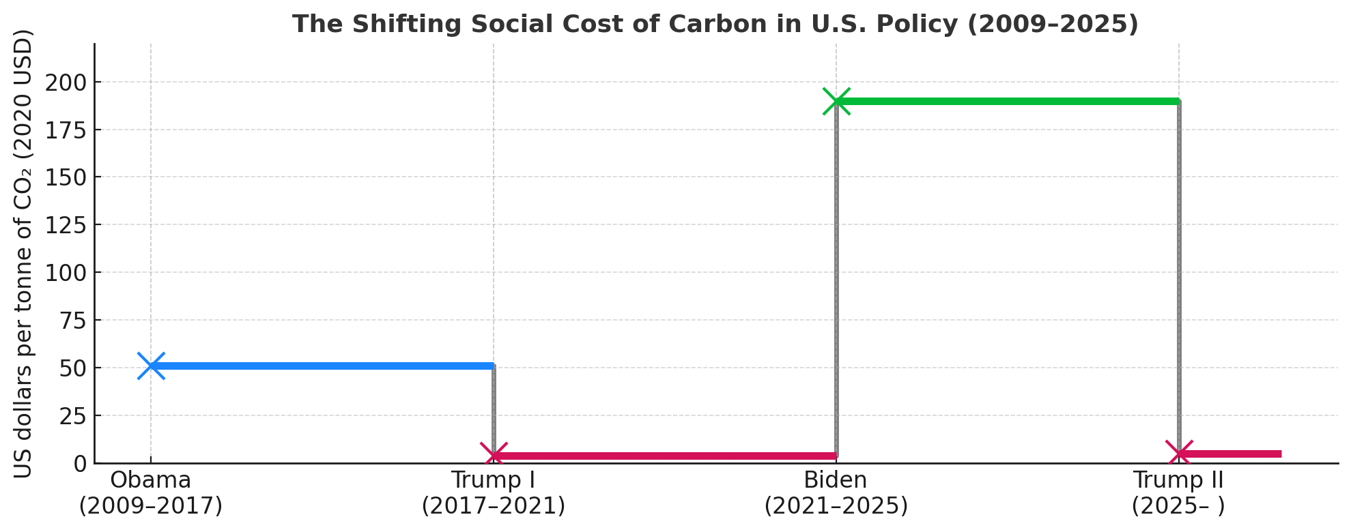
This debate highlights how normative choices—in this case, about discounting—can shift IAM results by an order of magnitude. Despite controversy, for example related to discount rates, IAM-based SC-CO₂ estimates remain the cornerstone of climate-policy appraisal in the United States and a benchmark for many other governments.

How to read IAM results
The best way to interpret IAMs is as “what-if” scenarios rather than forecasts. They explore possible futures under different assumptions about technology, policy, and human behaviour, rather than providing predictions of what will happen. The results depend heavily on the parameters chosen, such as the discount rate or IPCC scenario chosen. Understanding these inputs is essential before drawing conclusions from any model outcome.
Focus on direction and magnitude, not precision. For example, one IAM may suggest an SC-CO₂ of $80/tCO₂ and another $120/tCO₂, but both agree on the core message: the carbon prices and taxes currently levied are too low. Similarly, across IPCC scenarios, faster decarbonisation almost always lowers long-term damages, even if short-term costs rise.

Why you should care
If you have ever read that a carbon tax should be $100/tCO₂, or that global emissions must fall by half in the next decade, the chances are those figures came from an IAM. IAMs act as the translation layer between scientific warnings and macroeconomic decision-making.
They matter because they shape the very policies and debates that determine our collective future. Understanding their role, and their limits, is essential for anyone working in climate policy.

Takeaway
IAMs are not perfect, but they are indispensable. They help us see the consequences of today’s choices, compare policy tools, and chart possible paths towards a stable climate.
From the IPCC’s global scenarios to the US government’s shifting SC-CO₂ estimates, IAMs illustrate how assumptions about economics and ethics translate directly into policy outcomes.
This article opens our series on Integrated Assessment Models. In future articles, we will explore how these models measure climate damages, weigh fairness, value the future, and imagine the technologies that could shape a low-carbon world.

Nordhaus, W. D. (1975). “Can We Control Carbon Dioxide?” Cowles Foundation Discussion Paper No. 443.
Nordhaus, W. D. (2018). “Projections and Uncertainties about Climate Change in an Era of Minimal Climate Policies.”
Do not worry if you are unaware of carbon budgets either, they are also explained in the helpful box below.
IPCC (2021). “Sixth Assessment Report: Mitigation of Climate Change.”
These SSPs are widely used across climate literature, providing a common baseline that makes it easier to understand what drives differences in model results.
UNFCCC (2021). “Glasgow Climate Pact.”
Some major federal agencies, including parts of the Department of Defense, have not systematically incorporated the SC-CO₂ in their analyses, meaning the metric has never been applied across the full US economy.
U.S. Environmental Protection Agency (2023). “Technical Support Document: Social Cost of Greenhouse Gases.”

